# AUTOMATED REAL-TIME STREET LIGHT FAULT DETECTION USING IOT

## A PROJECT REPORT

***Submitted by***

**SUBHIKSHAA S (2116210701264)**

**SUDHARSAN S (2116210701266)**

**TAMIL PRIYA V (2116210701282)**

***in partial fulfillment for the award of the degree of***

**BACHELOR OF ENGINEERING**

***in***

## COMPUTER SCIENCE AND ENGINEERING



**RAJALAKSHMI ENGINEERING COLLEGE ANNA UNIVERSITY, CHENNAI**

**MAY 2024**

# RAJALAKSHMI ENGINEERING COLLEGE, CHENNAI

**BONAFIDE CERTIFICATE**

Certified that this Thesis titled **“AUTOMATED REAL-TIME STREET LIGHT FAULT DETECTION USING IOT**” is the bonafide work of “**SUBHIKSHAA (2116210701264), SUDHARSAN S (2116210701266), TAMIL PRIYA V (2116210701282)”** who carried out the work under my supervision. Certified further that to the best of my knowledge the work reported herein does not form part of any other thesis or dissertation on the basis of which a degree or award was conferred on an earlier occasion on this or any other candidate.

## SIGNATURE

Dr. P. Shanmugam M.E., Ph.D.,

## PROJECT COORDINATOR

Associate Professor

Department of Computer Science and Engineering Rajalakshmi Engineering College

Chennai - 602 105

Submitted to Project Viva-Voce Examination held on **_**

**Internal Examiner External Examine**r

# ABSTRACT

This project aims to design an automated system to identify the real-time fault in street lights using Internet of Things (IoT) technology. The street light’s status is monitored continuously. The system integrates sensors and IoT devices into the street light infrastructure to monitor light status and when a fault occurs, which may lead to malfunction of the lights, alerts are instantly transmitted to maintenance personnel for swift repairs. By equipping each light fixture with a network of sensors, the system continuously monitors the operational status of individual lights and surrounding light levels. This approach not only enhances energy efficiency by ensuring timely maintenance, thus reducing energy wastage attributed to faulty lights; but also improves public safety and convenience by promptly addressing lighting issues. It also eliminates the need for manual reporting, enabling faster identification and repair of malfunctioning lights. The system's design emphasizes scalability, affordability, and ease of implementation, making it suitable for deployment in urban environments of varying sizes. This solution paves the way for a more sustainable approach to the urban lighting environment.

# ACKNOWLEDGMENT

First, we thank the almighty god for the successful completion of the project. Our sincere thanks to our chairman **Mr. S. Meganathan B.E., F.I.E.,** for his sincere endeavor in educating us in his premier institution. We would like to express our deep gratitude to our beloved Chairperson **Dr. Thangam Meganathan Ph.D.,** for her enthusiastic motivation which inspired us a lot in completing this project and Vice Chairman **Mr. Abhay Shankar Meganathan B.E., M.S.,** for providing us with the requisite infrastructure.

We also express our sincere gratitude to our college Principal,

**Dr. S. N. Murugesan M.E., PhD.,** and **Dr. P. KUMAR M.E., PhD, Director computing and information science , and Head Of Department of Computer Science and Engineering** and our project coordinator **Dr. P. Shanmugam, M.E., Ph.D.,** for her encouragement and guiding us throughout the project towards successful completion of this project and to our parents, friends, all faculty members and supporting staffs for their direct and indirect involvement in successful completion of the project for their encouragement and support.

**SUBHIKSHAA S SUDHARSAN S TAMIL PRIYA V**

## TABLE OF CONTENTS

|  |  |  |
| --- | --- | --- |
| **CHAPTER NO.** | **TITLE** | **PAGE NO.** |
|  | **ABSTRACT** | **iii** |
|  | **LIST OF TABLES**  **LIST OF FIGURES** | **v**  **vii** |

1. **INTRODUCTION 1**
   1. PROBLEM STATEMENT
   2. SCOPE OF THE WORK
   3. AIM AND OBJECTIVES OF THE PROJECT
   4. RESOURCES
   5. MOTIVATION

## LITERATURE SURVEY 4

* 1. SURVEY
  2. EXISTING SYSTEM
  3. PROPOSED SYSTEM

## SYSTEM DESIGN 8

* 1. GENERAL
  2. SYSTEM ARCHITECTURE DIAGRAM
  3. DEVELOPMENT ENVIRONMENT
     1. HARDWARE REQUIREMENTS
     2. SOFTWARE REQUIREMENTS

## PROJECT DESCRIPTION 10

* 1. METHODOLOGY
  2. MODULE DESCRIPTION

## RESULTS AND DISCUSSIONS 13

* 1. FINAL OUTPUT
  2. RESULT

## CONCLUSION AND FUTURE ENHANCEMENT 16

* 1. CONCLUSION
  2. FUTURE ENHANCEMENT

## REFERENCES 20

|  |  |  |
| --- | --- | --- |
|  | **LIST OF FIGURES** |  |
| **FIGURE NO** | **TITLE** | **PAGE NO** |
| 2.3 | INFERENCE DIAGRAM | 5 |
| 3.1 | SYSTEM ARCHITECTURE | 6 |
| 3.2 | SEQUENCE DIAGRAM | 8 |
| 4.1 | CONCEPTUAL ARCHITECTURE | 11 |
| 5.1 | OUTPUT | 25 |

**CHAPTER 1**

**INTRODUCTION**

In the midst of the society, a rural area faces many conflicts with unreachable solutions for most of the problems that they face every day. One such problem is street light functioning. Being a more important need at the night time, the functioning of street light is one of the biggest concerns among people. But when a malfunctioning of the street light is identified, the hassle of reporting it manually is a challenge. These inefficiencies may lead to affecting the day-to-day life of a citizen.

To address this problem, an automated street light fault detection system using IoT is the aim of our project. By harnessing the power of Internet of Things technology, we seek to revolutionize how street lights are monitored and maintained in rural areas. This system will utilize sensors and connectivity devices embedded within the street light infrastructure to detect faults such as bulb failures or circuit malfunctions in real-time. By automating the fault detection process, we aim to eliminate the need for manual reporting, thus streamlining the maintenance workflow and reducing response times significantly. This proactive approach not only ensures the timely repair of faulty street lights but also minimizes disruptions to daily life for citizens. Ultimately, our goal is to create a more efficient and reliable street lighting system that enhances safety and convenience for residents in rural communities.Top of Form

By introducing IoT solutions tailored to the specific needs of rural communities, we aim to bridge the gap between urban and rural areas in terms of access to modern amenities and services. This implementation contributes to energy consumption efforts by addressing malfunctioning of street lights.

## PROBLEM STATEMENT

The challenge is to develop an automated system for real-time street light fault detection, precise location tracking, and efficient maintenance in cities to enhance urban lightning infrastructure. The problem of detecting the fault in street lights such that it does not function even when the power is on. This issue may lead to prolonged period of darkness and cause inconvenience among people.

## SCOPE OF THE WORK

The scope of our project encompasses the development and implementation of an automated system for real-time street light fault detection and efficient maintenance within urban areas. Focusing on enhancing the existing urban lighting infrastructure, our aim is to revolutionize the way cities manage and maintain their street lighting systems. This project will involve the deployment of sensors and connectivity devices integrated into street lights to enable continuous monitoring of their status.

## 1.3AIM AND OBJECTIVES OF THE PROJECT

The aim of our project is to develop and implement an automated system for real-time street light fault detection and efficient maintenance in urban areas. The automated street light fault detection system acts upon its name to detect the fault whenever a light is not functioning properly. The respective station will receive an alert about the fault. Our objectives include deploying sensors and connectivity devices within street lights for continuous monitoring, detecting malfunctions in real-time, enabling swift maintenance responses, and optimizing maintenance schedules and energy usage. By revolutionizing the management of urban lighting infrastructure, we seek to enhance public safety, reduce downtime, and contribute to the overall sustainability of urban environments through improved operational efficiency and cost savings.

## RESOURCES

This project has been developed through widespread secondary research of accredited manuscripts, standard papers, business journals, white papers, analysts' information, and conference reviews. Significant resources are required to achieve an efficacious completion of this project.

The following prospectus details a list of resources that will play a primary role in the successful execution of our project:

* + - A properly functioning IoT components such as Arduino UNO, Node MCU module, LDR sensor.
    - Other connecting components like jumper wires, LEDs.
    - Unrestricted access to the university lab in order to gather a variety of literature including academic resources (for e.g. Prolog tutorials, online programming examples, bulletins, publications, e-books, journals etc.), technical manuscripts, etc.

## MOTIVATION

The motivation behind this project stems from the pressing need to overcome the inefficiencies and challenges inherent in current urban lighting infrastructure. The manual methods of detecting street light faults are time-consuming and often ineffective, leading to prolonged periods of darkness in cities. This not only compromises public safety but also results in unnecessary energy wastage and increased operational costs for municipal authorities. By developing an automated system for real-time fault detection, and efficient maintenance, we aim to revolutionize urban lighting management. Our motivation lies in enhancing public safety, minimizing downtime, reducing energy consumption, and ultimately contributing to the overall sustainability.

**CHAPTER 2**

**LITRETURE SURVEY**

The research by Kiran and Prachi [1] employs the use of a Mobile application that provides a user based login where the status of the faulty street lights are being reported. Once the street lights are repaired concerned servicemen should scan their RFID to the reader which sends a notice to the application that the particular fault has been repaired by this concerned person. They use GPS for tracking functions.

The paper by P. Karthikeyan et al. [2] details a smart street light system that uses IoT for automated control and fault detection. It combines centralized data management with decentralized, real-time responses to traffic and weather conditions, enhancing energy efficiency. NBIoT technology ensures robust and efficient communication between lights and the control center, making the system scalable and secure​.

The paper "IoT Based Smart Street Lighting System" by Prashanth S. U. et al. [3] presents an advanced street lighting solution using IoT technology to enhance energy efficiency and automation. The system integrates motion sensors, light-dependent resistors (LDRs), and infrared (IR) sensors to dynamically adjust light intensity based on real-time environmental conditions and traffic movement. Controlled via the ESP8266 microcontroller, it uses Wi-Fi for data communication and can be monitored and managed remotely. This setup reduces power consumption and operational costs while ensuring adequate lighting and improved maintenance through real-time fault detection and automatic updates.

The paper by D.K. Saini et al. [4] presents an innovative approach to streetlight control through vehicle movement detection, published in "Advances in Energy Technology" by Springer in 2022. The authors address the pressing issue of energy conservation and propose a system that automatically adjusts streetlight intensity based on vehicle presence. This literature review contextualizes the study within the broader field of energy-efficient street lighting systems. Prior research has explored various methods to optimize energy usage in street lighting, including timer-based systems and motion sensors. However, these approaches often suffer from inefficiencies or lack adaptability. Saini et al.'s solution offers a promising alternative by leveraging vehicle detection technology, which ensures lights are only active when needed, thus reducing energy waste. This paper contributes valuable insights to the field, offering a practical solution to enhance energy efficiency in urban lighting infrastructure.

The paper "Street Light Controlling and Monitoring of Fault Detection using LoRa" by Sravani et al. [5] explores the use of LoRa technology for smart street lighting systems. The proposed system allows for remote control and monitoring of street lights, enhancing operational efficiency and reducing energy consumption. It employs LoRa for long-range, low-power communication, enabling real-time fault detection and status updates. The system's architecture supports scalability and reliability, making it suitable for urban and rural deployment. This work demonstrates the effectiveness of integrating IoT and LoRa technology for modernizing street lighting infrastructure​.

The paper "IoT Based Automatic Damaged Street Light Fault Detection Management System" by A. K. Nanduri, S. Kumar, and S. Ratna [6] presents a system utilizing IoT for the automation and management of street light fault detection. The system employs various sensors to monitor street light performance and detect faults in real-time. Data is transmitted via IoT networks to a central management system, enabling prompt maintenance actions. This approach enhances energy efficiency, reduces manual inspection, and ensures timely fault resolution, demonstrating significant improvements over traditional street light management systems in terms of responsiveness and operational efficiency​.

The paper by Ashok Kumar Nanduri et al. titled "IoT based Automatic Damaged Street Light Fault Detection Management System," [7] published in the International Journal of Advanced Computer Science and Applications in 2020, introduces an IoT-driven approach to detect and manage faults in street lighting infrastructure. This literature review examines the paper in the context of existing research on smart city technologies and IoT applications in urban infrastructure management. Previous studies have investigated various IoT solutions for streetlight monitoring and fault detection, aiming to enhance operational efficiency and reduce maintenance costs. Nanduri et al.'s system stands out for its emphasis on automatic fault detection and management, facilitated by IoT sensors and real-time data analytics. By proactively identifying and addressing faulty streetlights, the proposed system offers potential benefits in terms of improved safety, energy conservation, and resource optimization. This paper contributes to the growing body of literature on IoT-enabled smart city solutions, offering practical insights into enhancing urban infrastructure management.

The paper by C. Subramani et al. titled "Energy Efficiency and Pay-Back Calculation on Street Lighting Systems," [8] presented at the 11th National Conference on Mathematical Techniques and Applications in 2019, addresses the critical issue of energy efficiency in street lighting systems. This literature review contextualizes the study within the broader field of energy optimization in urban infrastructure. Previous research has explored various strategies to enhance the energy efficiency of street lighting, including the use of LED technology, smart lighting controls, and energy management systems. Subramani et al.'s paper contributes to this discourse by focusing on pay-back calculation methodologies, providing a systematic approach to evaluate the economic feasibility of energy-saving initiatives. By integrating mathematical techniques with practical considerations, the authors offer valuable insights into decision-making processes for street lighting upgrades and investments. This study serves as a significant contribution to the ongoing efforts to promote sustainability and cost-effectiveness in urban lighting infrastructure.

The paper "National Highway Street Light Faulty Detection and Monitoring System" [9] from the International Journal of Emerging Technologies and Innovative Research discusses an IoT-based approach for monitoring and detecting faults in street lights. It uses sensors and microcontrollers to gather real-time data on street light performance, transmitting this data to a central system via Wi-Fi for analysis. The system employs the Blynk app for real-time monitoring and cloud storage, improving maintenance efficiency and reducing energy consumption by promptly identifying and addressing faulty street lights.​

The paper "Automatic Street Light Control and Fault Detection Using Node-MCU" by T. S. Kumar et al. [10] presents a system leveraging Node-MCU for the automation and fault detection of street lights. The system integrates sensors and microcontrollers to enable automatic switching based on ambient light levels and fault detection via current monitoring. This setup enhances energy efficiency and reduces manual intervention. The use of Node-MCU facilitates real-time data communication and control through IoT platforms, ensuring scalability and ease of implementation in urban infrastructure​.

.

## CHAPTER 3 SYSTEM DESIGN

**3.1 GENERAL**

In this section, we would like to show how the general outline of how all the components end up working when organized and arranged together. It is further represented in the form of a flow chart below.

## 3.2 SYSTEM ARCHITECTURE DIAGRAM

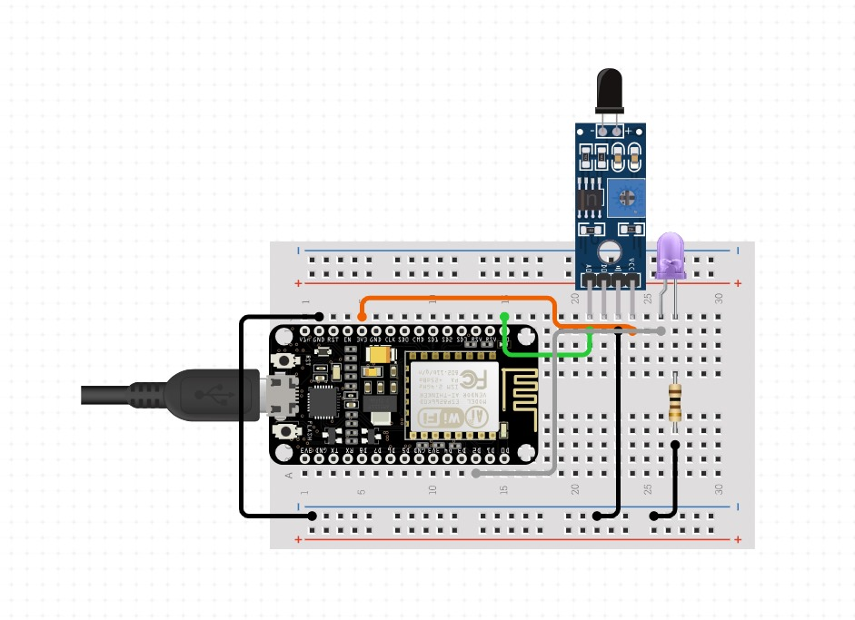

**Fig 3.1: System Architecture**

## 3.3 DEVELOPMENTAL ENVIRONMENT

**3.3.1 HARDWARE REQUIREMENTS**

The hardware requirements may serve as the basis for a contract for the system’s implementation. It should therefore be a complete and consistent specification of the entire system. It is generally used by software engineers as the starting point for the system design.

## Table 3.1 Hardware Requirements

|  |  |
| --- | --- |
| **COMPONENTS** | **SPECIFICATION** |
| Arduino UNO | ATmega328P |
| LDR sensor | 3- 5V operating voltage |
| 12V lamp adapter | 12V DC |
| LED bulbs | 3-5V DC |
| ESP 8266 Wi-Fi Module | IEEE 802.11 b/g/n standard |
| Resistors | As per required |
| Transistor boards | MOSFET |
| Bread Board | Full-size |
| Jumper wires | Male-to-male, male-to-female, and female-to-female jumper wires |

**3.3.2 SOFTWARE REQUIREMENTS**

The software requirement is Arduino IDE to code the functionalities to be performed. The Arduino Integrated Development Environment (IDE) is a software platform for programming Arduino microcontroller boards, offering a user-friendly interface to write, compile, and upload code.

**CHAPTER 4**

**PROJECT DESCRIPTION**

## 4.1 METHODOLODGY

## 

The methodology for implementing the automated street light fault detection system using IoT technology involves several key steps. Hardware selection is meticulously conducted, taking into account the specific requirements of the project. Components such as the Arduino UNO microcontroller, LDR sensor for light detection, ESP 8266 Wi-Fi Module for communication, and associated accessories like resistors, transistor boards, breadboards, and jumper wires are chosen based on their compatibility, functionality, and availability. Following hardware selection, the integration process begins. Each hardware component is carefully connected and wired according to predefined specifications. Detailed step-by-step instructions or schematic diagrams are provided to ensure accurate assembly and connectivity. Once the hardware integration is complete, software development commences. Programming logic is implemented on the Arduino UNO to read sensor data, control LED bulbs, and communicate with the ESP 8266 Wi-Fi Module. Throughout the development process, rigorous testing is conducted to verify the system's reliability and accuracy. Test scenarios include normal operation, fault simulation, and communication integrity checks. Test results are meticulously recorded and analyzed to identify any discrepancies or issues that require resolution. With the hardware, software, and testing phases completed, a deployment strategy is proposed. This strategy outlines the logistics of installing the system in urban environments, addressing considerations such as scalability, maintenance requirements, and deployment logistics. Performance evaluation is conducted to assess the system's efficiency and effectiveness. Key performance metrics include energy efficiency, fault detection time, and maintenance response time.

## 4.2 MODULE DESCRIPTION

**1. Arduino UNO (ATmega328P):**

The Arduino UNO serves as the core microcontroller unit of the system. It is responsible for interfacing with various sensors, controlling LED bulbs, and managing communication with the ESP 8266 Wi-Fi Module. The ATmega328P microcontroller offers sufficient processing power and I/O capabilities to handle the system's tasks efficiently.

**2. LDR Sensor (Light Dependent Resistor):**

The LDR sensor detects ambient light levels in the vicinity of the street light. Operating within a voltage range of 3-5V, it provides analog voltage output corresponding to the intensity of light. By continuously monitoring light levels, the LDR sensor enables the system to detect abnormalities or faults in the illumination of street lights.

**3. ESP 8266 Wi-Fi Module:**

The ESP 8266 Wi-Fi Module facilitates wireless communication between individual street light units and the central monitoring system. Operating on the IEEE 802.11 b/g/n standard, it enables real-time data transmission over Wi-Fi networks. Equipped with a powerful microcontroller unit and onboard Wi-Fi antenna, the ESP 8266 module ensures reliable connectivity and seamless integration into the IoT ecosystem.

**4. 12V Lamp Adapter:**

The 12V lamp adapter serves as the power source for the LED bulbs used in the street lights. Delivering a stable 12V DC output, it ensures consistent illumination while minimizing power consumption. The adapter is designed to withstand outdoor conditions and provide long-term reliability in street light installations.

**5. LED Bulbs:**

LED bulbs are utilized as the primary light source in the street light fixtures. Operating on 3-5V DC power, they offer high energy efficiency, long lifespan, and instant illumination. The low voltage requirement makes them compatible with the system's power supply and ensures optimal performance in outdoor environments.

**6. Resistors:**

Resistors are employed in the system to regulate current flow, limit voltage, and protect electronic components from damage. Their values are selected based on specific application requirements, such as current limiting for LEDs or voltage division in sensor circuits. Proper resistor selection ensures stable operation and prevents overheating or overloading of components.

**7. Transistor Boards (MOSFET):**

Transistor boards, particularly MOSFETs (Metal-Oxide-Semiconductor Field-Effect Transistors), are used for switching and amplifying signals in the system. MOSFETs provide efficient voltage regulation and power management, allowing precise control over the LED bulbs' brightness levels. Their low ON-resistance and high switching speed make them ideal for applications requiring fast response times and minimal power losses.

**8. Breadboard and Jumper Wires:**

The full-size breadboard and assorted jumper wires facilitate prototyping and circuit assembly. They enable easy connection and reconfiguration of components during development and testing phases. Male-to-male, male-to-female, and female-to-female jumper wires provide flexibility in wiring layouts and ensure compatibility with different component configurations.

## CHAPTER 5

**RESULTS AND DISCUSSIONS**

## OUTPUT

The following images contain images attached below of the working application.

Example instance of reporting faulty condition

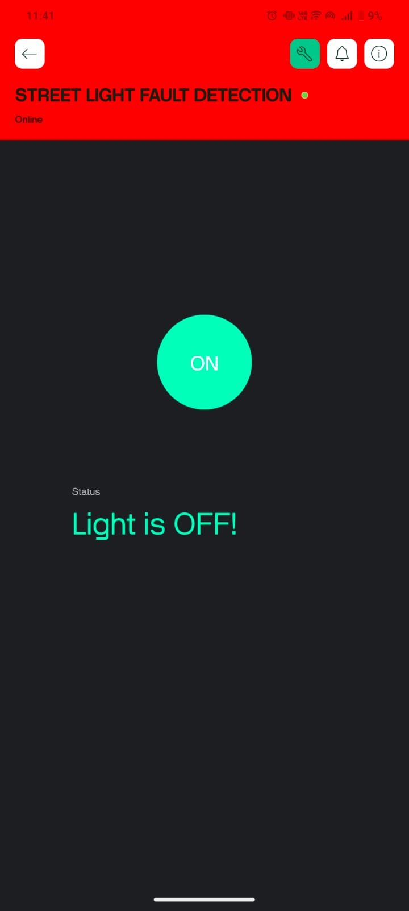

## Fig 5.1: Output

## Live demonstration:

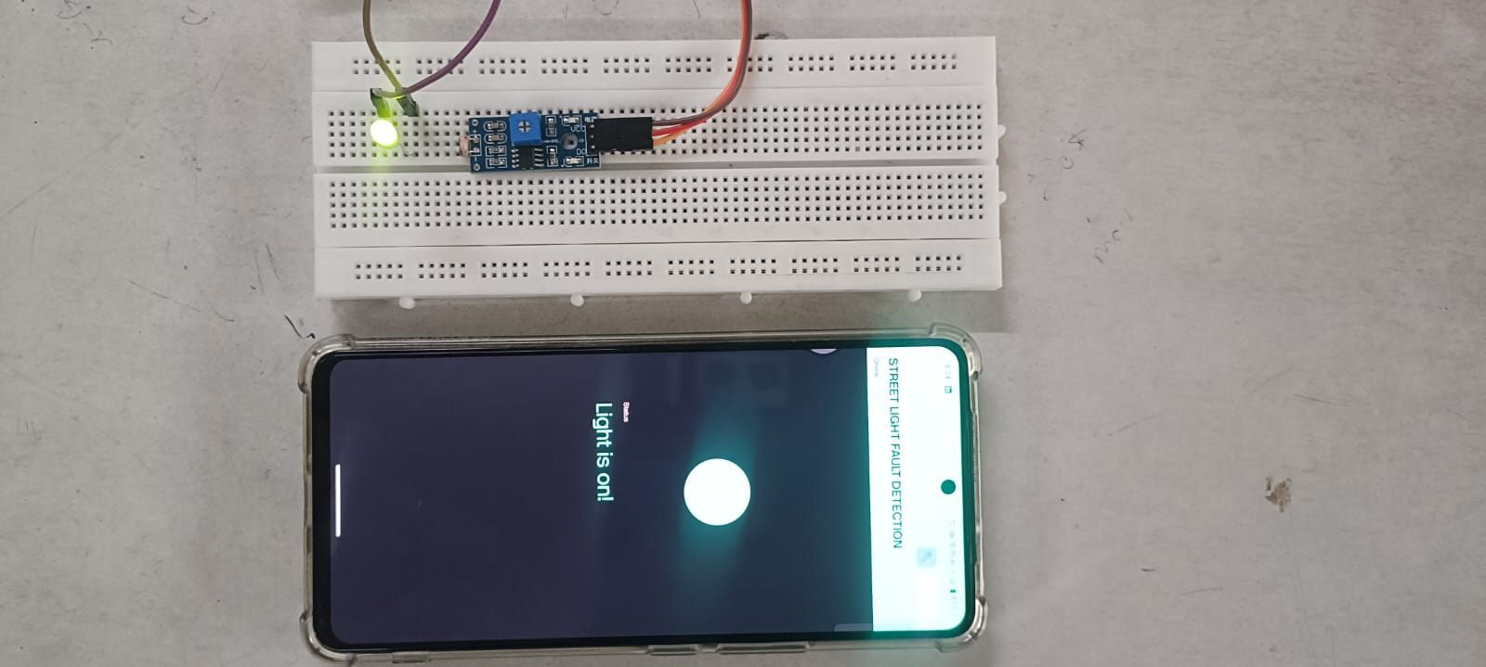

## 

## Fig 5.2: During ON condition

## Project setup:

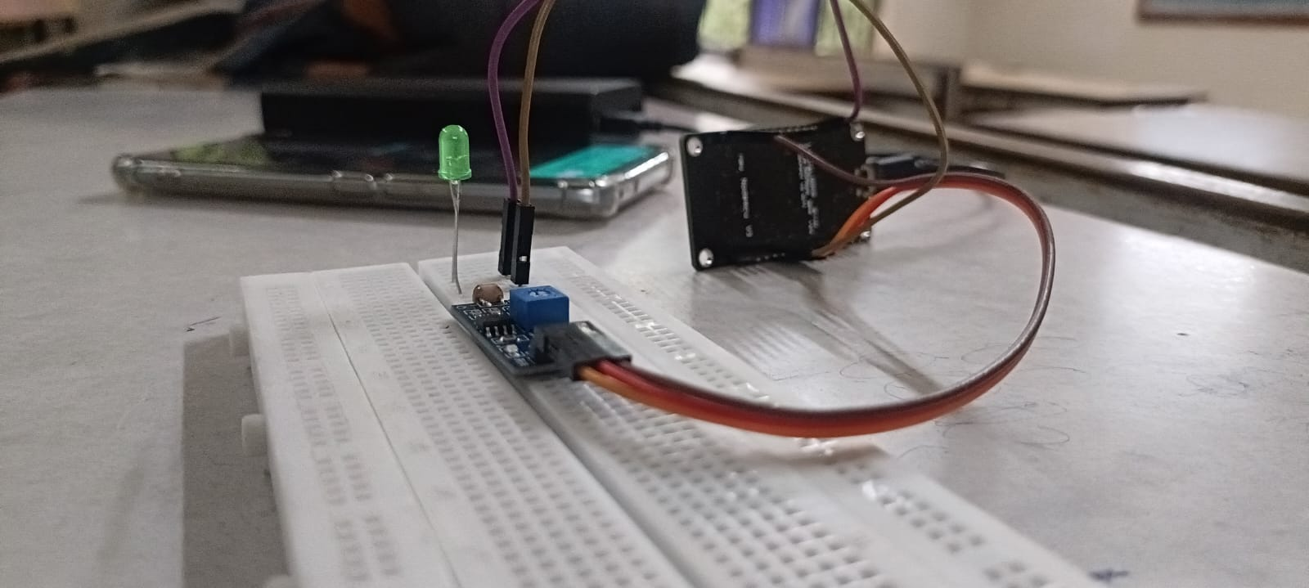

## 

## Fig 5.3: Project setup

* 1. **RESULT**

The automated street light fault detection system using IoT technology is anticipated to yield several significant results, benefiting both urban infrastructure management and community safety. By continuously monitoring light levels using LDR sensors and integrating data from individual street light units via the ESP 8266 Wi-Fi Module, the system can accurately identify abnormalities in illumination levels or operational status. This monitoring capability is expected to significantly reduce the time required to detect and address lighting issues compared to traditional manual inspection methods. Moreover, the system is designed to enhance energy efficiency by ensuring timely maintenance of faulty street lights. By promptly detecting and reporting faults, such as burnt-out bulbs or malfunctioning components, energy wastage attributed to inefficient lighting can be minimized. This proactive approach to maintenance not only reduces electricity consumption and associated costs but also contributes to environmental sustainability by decreasing carbon emissions and energy consumption. It also enhances public safety and convenience by ensuring consistent and reliable street lighting. Properly illuminated streets promote visibility, deter criminal activities, and enhance pedestrian safety, particularly during nighttime hours. By promptly addressing lighting issues, the system helps create safer and more secure urban environments, fostering community well-being and confidence. .By leveraging IoT technology to monitor and manage street lighting infrastructure, the system represents a significant step towards creating smarter, more resilient, and sustainable cities.

## CHAPTER 6

**CONCLUSION AND FUTURE ENHANCEMENT**

## 6.1 CONCLUSION

In the In conclusion, the implementation of the automated street light fault detection system utilizing IoT technology presents a promising solution for enhancing urban infrastructure management and community safety. By enabling real-time monitoring of street light status and prompt detection of faults, the system offers numerous benefits including improved energy efficiency, enhanced public safety, and streamlined maintenance operations. Through the integration of hardware components such as Arduino UNO, LDR sensors, and ESP 8266 Wi-Fi Module, coupled with robust software development and rigorous testing, the system provides a reliable and scalable solution for proactive street light management. Moving forward, the successful deployment and operation of this system have the potential to revolutionize urban lighting infrastructure, paving the way for smarter, more sustainable cities.

## 6.2 FUTURE ENHANCEMENT

One potential enhancement is the integration of advanced data analytics and machine learning algorithms to predict and preemptively address potential faults before they occur, further improving system efficiency and reliability. Additionally, incorporating additional sensors, such as motion detectors or environmental sensors, could enable the system to provide supplementary functionalities such as adaptive lighting based on pedestrian or vehicular activity, or environmental conditions like weather or air quality.

**APPENDIX**

**SOURCE CODE:**

#define BLYNK_TEMPLATE_ID "TMPL35Ewp7wTw"

#define BLYNK_TEMPLATE_NAME "LDR"

#define BLYNK_AUTH_TOKEN "FJPt5b4DLqtgl0EOX6UydWG1zNug3aYn"

#define BLYNK_PRINT Serial

#include <ESP8266WiFi.h>

#include <BlynkSimpleEsp8266.h>

char auth[] = BLYNK_AUTH_TOKEN;

char ssid[] = "Sudharsan";  // type your WiFi name

char pass[] = "nottu123";  // type your WiFi password

const int ldrPin = A0;  // LDR connected to analog pin A0

const int ledPin = D4;  // GPIO pin D4 connected to LED bulb

const int buttonPin = V2;  // Virtual pin V2 for the Blynk button

bool ledState = false;  // Variable to track LED state

bool buttonStatePrev = false;  // Variable to track previous button state

void sendSensor() {

  int ldrValue = analogRead(ldrPin);

  bool buttonState = digitalRead(buttonPin);

  if (ldrValue > 320) {  // Adjust threshold based on LDR sensitivity

    Serial.println("Light is OFF");

    Blynk.virtualWrite(V1, "Light is OFF! "); // Send notification-like message to Blynk app using Virtual Pin V1

    digitalWrite(ledPin, LOW); // Turn off LED

    ledState = false;  // Update LED state variable

  } else {

    Serial.println("Light is ON");

    Blynk.virtualWrite(V1, "Light is ON!");

    if (!ledState) {  // Check if LED was previously off

      digitalWrite(ledPin, HIGH); // Turn on LED only if it was off

      ledState = true;  // Update LED state variable

    }

  }

  buttonStatePrev = buttonState;  // Update previous button state

}

BLYNK_WRITE(buttonPin) {  // Blynk virtual pin V2 callback function

  int buttonState = param.asInt();  // Get value from Blynk app button (0 or 1)

  if (buttonState == 1) {  // If button is turned on

    sendSensor();  // Call sendSensor to check LDR and control LED

  } else {  // If button is turned off

    digitalWrite(ledPin, LOW); // Turn off LED

    ledState = false;  // Update LED state variable

  }

}

void setup() {

  pinMode(ldrPin, INPUT);

  pinMode(ledPin, OUTPUT);

  pinMode(buttonPin, INPUT_PULLUP);  // Set buttonPin as input with internal pull-up resistor

  Serial.begin(115200);

  Blynk.begin(auth, ssid, pass);

}

void loop() {

  Blynk.run();

}

## REFERENCES

[1] [“Website.” [Online]. Available:](http://paperpile.com/b/XmecgY/mSoC) www.ijcrt.org © 2023 IJCRT | Volume 11, Issue 11 November 2023 | ISSN: 2320-2882 IJCRT2311315 International Journal of Creative Research Thoughts (IJCRT) www.ijcrt.org

[2] [P. Karthikeyan, M. Karthik, V. Deepikapriya, S. Divya Briya, R. Dharanishwarma, and S. Janakirthick, “Design and implementation of smart street light automation and fault detection system,” in *2022 2nd International Conference on Power Electronics & IoT Applications in Renewable Energy and its Control (PARC)*, IEEE, Jan. 2022. doi:](http://paperpile.com/b/XmecgY/UNMI) [10.1109/parc52418.2022.9726622.](http://dx.doi.org/10.1109/parc52418.2022.9726622.)

[3] Prashanth. S U et al, “IoT Based Smart Street Lighting System,” International Journal of Engineering Research & Technology (IJERT), Volume 10, No. 08, 2022.

[4] D.K. Saini et al, "Auto Streetlight Control with Detecting Vehicle Movement," Advances in Energy Technology, Springer, Singapore, pp. 279-288, 2022

[5] Sravani, N & Latha, Y & Nirmala, G & Ijmtst, Editor. (2021). Street Light Controlling and Monitoring of Fault Detection using LoRa. International Journal for Modern Trends in Science and Technology. 7. 242-245.

[6] [A. K. Nanduri, S. Kumar, and S. Ratna, “IoT based automatic damaged street light fault detection management system,” *Int. J. Adv. Comput. Sci. Appl.*, vol. 11, no. 8, 2020, doi:](http://paperpile.com/b/XmecgY/HiPZ) [10.14569/ijacsa.2020.0110853.](http://dx.doi.org/10.14569/ijacsa.2020.0110853.)

[7] Ashok Kumar Nanduri et al, “IoT based Automatic Damaged Street Light Fault Detection Management System,” (IJACSA) International Journal of Advanced Computer Science and Applications, Vol. 11, No. 8, 2020.

[8] C. Subramani et al., "Energy Efficiency and Pay-Back Calculation on Street Lighting Systems," The 11th National Conference on Mathematical Techniques and Applications, AIP Conf. Proc., vol. 2310, no. 1, 2019.

[9] "National Highway Street Light Faulty Detection and Monitoring System", International Journal of Emerging Technologies and Innovative Research (www.jetir.org), ISSN:2349-5162, Vol.6, Issue 4, page no.442-450, April-2019, Available :[http://www.jetir.org/papers/JETIR1904D58.pdf](https://www.jetir.org/papers/JETIR1904D58.pdf)

[10] [T. S. Kumar, G. J. Rao, J. A. Ramana, M. C. Sai Ganesh. B, T. Vennela, and M. M. Krishna, “Automatic street light control and fault detection using node - MCU,” *Int. J. Sci. Res. Sci. Eng. Technol.*, pp. 256–261, Mar. 2019.](http://paperpile.com/b/XmecgY/PkKg)

[11] G.PRAVEEN et al , “National Highway Street Light Faulty Detection & Monitoring System,” Journal of Emerging Technologies and Innovative Research (JETIR), Volume 6, No. 4, April 2019.

[12] G Prathib Kumar, N Yashaswini, N Raghu and S Yashaswini, "Automatic Street Light Control by Detecting Vehicle Movement", *3rd IEEE International Conference on Recent Trends in Electronics Information & Communication Technology*, 2018.

[13] Smita A. Bhosale and Tejaswini Ankalkote, "Modern Street Lighting System with Intensity Control based on Vehicle Movements and Atmospheric Conditions using Zigbee", *2018 International Conference on Information Communication Engineering and Technology (ICICET)*, pp. 1-4, 2018.

[14] Piyush Saini, Pateek Saini, Ajay Kumar Jangid and Udit Mamodiya, "A Smart Street Light System With Auto Fault Detection", *Pramana Research Journal*, vol. 8, no. 8, 2018.

[15] Omkar Rudrawar, Siddharth Daga, Janak Raj Chadha and P. S. Kulkarni, "Smart Street Lighting System with Light Intensity Control using Power Electronics", *2018 Technologies for Smart-City Energy Security and Power (ICSESP)*, 2018.

[16] Abdul Latif Saleem et al., "Street Light Monitoring and Control System," International Journal of Engineering and Techniques, vol. 1, no. 2, pp. 242-245, 2015.

[17] V. Sumathi et al., "Arm Based Street Lighting System with Fault Detection," International Journal of Engineering and Technology, vol. 5, no. 5, pp. 3423-3427, 2013

[18] K.Y. Rajput et al., "Intelligent Street Lighting System Using Gsm," International Journal of Engineering Science Invention, vol. 2, no. 3, pp. 32-35, 2013.

[19] Mr. Amey J.Manekar, Dr. Dr. R .V. Kshirsagar ” Design and Implementation of Automatic Street Light Controller for Energy Optimization Using FPGA”, International Journal of Advanced Research in Computer and Communication Engineering Vol. 5, Issue 6, June 2016.

[20] Chaitanya Amin, AshutoshNerkar, Paridhi Holani, Rahul Kaul ”GSM Based Autonomous Street Illumination System for Efficient Power Management” International Journal of Engineering Trends and TechnologyVolume4Issue1- 2013.